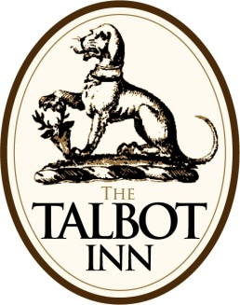
South East Trec Awards Dinner
The Talbot, High Street, Ripley, Surrey GU23 6BB
Friday 18th November 2011
Drinks in Main Bar from 7.30pm
Dinner served 8.30pm in Wisley Suite
3 Course Meal / Tea & Coffee £35 per head
Name ............................................................................................

Menu | Tick Selection
Starters
Vine roasted tomato & lentil soup
Smoked mackerel pate with dill bread
Mozzarella, Parma ham & tomato salad with mustard dressing
Main Course
Roast chicken supreme with bubble & squeak, fine green beans & shallot jus
Salmon & spinach lattice with chive mash & asparagus puree
Caramelised red onion tart with sweet bell peppers and goats cheese
Desserts
Crème Brulee
Ice cream & sorbets
Sticky Toffee Pudding
Rhubarb & stem ginger panna cotta
Cheese & biscuits with homemade chutney
If booking more than 1 place please send individual forms for your menu selections

Return form to Diane Cripps,41 Charles Babbage Close, Chessington, KT92SB
with a cheque payable to SE Trec Group for the full amount by
Wednesday 2nd November 2011
.
Bed & Breakfast Accomodation can be booked at the following room rates Classic Room £99 or Deluxe Room £129 . Call 01483 225188 to make your reservation and quote South East Trec Awards Dinner when booking.

www.bespokehotels.com/talbotinn

