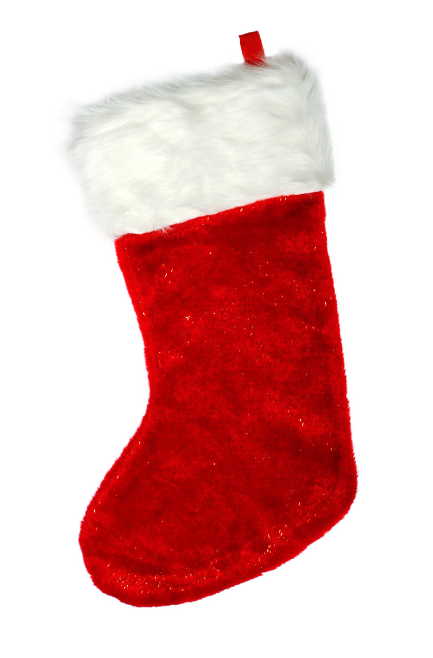
SOUTH EAST TREC GROUP

CHRISTMAS POR
SUNDAY 11th DECEMBER 2011
at
Newlands Corner, Surrey
OS Explorer map Grid reference TQ 044 493

Individual and Pairs Class.
Special prize for the best fancy dress!

TREC competitions appeal to any combination of horse and rider. The main emphasis is to enjoy yourself. This competition is only the orienteering section of Trec, but will be basic enough to encourage people to have a go.
As this is a Christmas fun ride we actively encourage you to turn up in fancy dress (suitable for riding distance), and there will be mulled wine, mince pies and Christmas Cake for you at the finish.

Competitors will be allocated a time to come to the map room for a compulsory equipment check and then riders will enter the map room. A map is displayed and riders have to copy the route from it onto another map (provided). The object is then to ride as accurately as possible along this route, enjoying the scenery.

Unfortunately we have to limit horse boxes to 7.5t weight limit, parking is very restricted, so please share horse transport if you can.

Classes;

Class 1 : Novice Individual ( Rider not to have been placed 1st-3rd in trec)
Class 2 : Novice Pairs ( Pair not to have been placed 1st – 3rd in trec)
Class 3 : Open Individual ( open to all)
Class 4 : Open Pairs ( open to all)

Classes are £20 per person ( £40 per pair) this covers affiliation to the BHS, administration and Rider donation to ride at Newlands corner.

The entry form should be accompanied by a valid email address for start times and directions to be sent out on 8th December. Closing date for entries is December 1st or earlier if classes are full. Numbers are restricted and will be on a first come first served basis.

Enquiries to bobcripps1@googlemail.com 07860 432065

If you do not have web access, your entry must be accompanied by a 1st class stamped, self addressed envelope for times and directions to be posted to you in the week before the competition.

Compulsory equipment
Compass
Map marking pens (narrow fluorescent works best)
Whistle
First Aid Kit
Headcollar and rope
Hi Viz ( even with fancy dress!)
ID on horse and rider (luggage tags/medical armband etc)

Recommended equipment
Map case
Mobile phone (switched off)
Digital watch
Writing pen/pencil

There will be no first aid attendance or vet on site, so First Aid cover is restricted to normal emergency call-out, and veterinary phone numbers can be supplied by the organiser.

Rules and conditions of entry.
1. The competition will be run in accordance with BHS TREC rules. A copy of the rules handbook is available from the BHS Bookshop tel 08701 201918.
2. Horses and ponies must be a minimum of four years old in 2011.
3. A hard hat must be worn conforming to standard PAS 015, EN1384 or ASTM F 1163 and bearing the kite mark of SEI.
- Suitable riding footwear must be worn.
- Standing martingales and other fixed reins are forbidden.
6. Whips must not exceed 75 cms. Spurs if worn must be rounded, not exceeding 3.5cms in length and pointed downwards.
7. Mobile phones may be carried for use in an emergency.
8. No entry fee will be refunded after the closing date except on production of a medical or veterinary certificate within five days of the competition.
9.Insurance – all riders must have public liability insurance. Riders who are members of an affiliated Riding Club or have BHS Gold membership must provide their current membership no. on the entry form. All other riders must provide a copy of their public liability insurance cover.
- No responsibility will be accepted by the organisers, their representatives or helpers for any loss or damage to spectators, competitors, their horses, grooms, friends or property under any circumstances whatever.
- Riders under the age of 14 on day of competition may only compete in Pairs classes with a rider of 16y or older.
- By making an entry you will be deemed to be in acceptance of the rules

Entry form Christmas Trec competition Sunday 11th December 2011

Class:_____ Level (Novice or Open) _____Individual or Pairs: ___________________

First Rider’s Name:______________________________________________ Address:_______________________________________________________ _______________________________________________________________
Current BHS/RC number:_________________
Email address:______________________________________________
Rider D.O.B: (if under 17) ______________ Telephone: __________________
Horse: ______________________ Height: __________________ Breed:__________________________ Year of Birth: ______________

Signature:...........................................................................................

Second Rider’s Name: ___________________________________________ Address:_______________________________________________________ _______________________________________________________________
Current BHS/RC number:_________________
Email address:___________________________________________________
Rider D.O.B: (if under 17) ______________ Telephone: __________________
Horse: ______________________ Height: _________________ Breed:__________________________ Year of Birth: ______________

Signature:.....................................................................................................................

I/We enclose a cheque for £ made payable to South East Trec Group. I/We have seen, read, understood and agree to abide by the rules.
Entries to: Bob Cripps, 41 Charles Babbage Close, Chessington, Surrey, KT9 2SB

